DungeonDiver3 Manual V2.0.0
Copyright © 2011-2012, Eric Ahnell.

This manual was last updated on May 4, 2012.

Questions / Bug reports / Suggestions

E-mail any questions, bug reports, or suggestions to us at: products@puttysoftware.com

ALWAYS include the version of DungeonDiver3 that you have. A lot of things change, and without the version number it is pretty tough to verify the problem. Please try to be as specific as possible. A comment such as, "It crashes all the time," is too vague, and will not be of any real value in correcting the problem. Try to describe where you were and what you were doing, along with your system configuration, and the log file containing details of the crash, if DungeonDiver3 crashed. Mac OS X users can use System Profiler, in the Utilities folder, to generate a system report of their system configuration.

About This Manual

This manual was created with LibreOffice 3.5. It was exported to PDF with the built-in Print to PDF feature. All the screen shots in this manual are from the Mac version of the game.

System Requirements

OS X: DungeonDiver3 requires any Intel Mac, running OS X 10.6 “Snow Leopard” or later, and 500 MB of free disk space.
Note for 10.7 “Lion” (and newer OS X versions) users: You'll need to download Java to run DungeonDiver3. This can be acquired on-demand, by launching Java Preferences in your Utilities folder, or any other application that makes use of Java – if you do not have Java, it will be downloaded and installed for you.
Windows: DungeonDiver3 requires any Intel or AMD CPU capable of running Windows XP or later, and 500 MB of free disk space. Java 6 or later is also required – to get this visit the Java website, if you do not already have it. You only need the JRE, not the JDK.
Linux: DungeonDiver3 requires any Intel or AMD CPU capable of running Linux 2.6 kernel or later, and 500 MB of free disk space. Java 6 or later is also required – to get this open up your favorite package manager, if you do not already have it. You only need the JRE, not the JDK.
Note for All Platforms: The latest available update to Java is strongly recommended.

The Menus – An Overview
File
Open Saved Game…: Opens an existing Saved Game.
Close: Closes the current window.
Save: Saves your progress as a Saved Game file.
Save As: Saves your progress as a Saved Game file, with a new name.
Print...: Prints the contents of the active window to a printer of your choosing.
Preferences: Allows configuration of various Game Settings. (On Mac OS X, this command is in the DungeonDiver3 Menu.)
Exit (non-Mac OS X platforms only): Quits the Program. (On Mac OS X, the Quit DungeonDiver3 command in the DungeonDiver3 menu does the same thing.)
Game
Play: Allows playing a randomly generated Scenario.
Show Equipment: Shows all Equipment you are wearing. This command is only available while playing a Scenario.
Show Inventory: Shows all Items you are carrying. This command is only available while playing a Scenario.
Pick Leader...: Changes the Character considered to be at the head of your Party. This command is only available while playing a Scenario.
Register Character: Adds a Character File to the list of registered files. This command is only available while NOT playing a Scenario.
Unregister Character: Removes a Character File from the list of registered files. This command is only available while NOT playing a Scenario.
Remove Character: Removes a Character File from the list of registered files, then deletes its corresponding disk file. Use with caution, as this operation is not undoable. This command is only available while NOT playing a Scenario.
Edit Note...: While playing a Scenario, allows you to leave notes behind for later.
View Prestige...: Displays the party leader's prestige score, along with all the components that comprise it. This command is only available while playing a Scenario.
View Current Score...: Displays your overall game score. This is separate from Prestige, which is specific to each character. This command is only available while playing a Scenario.
View Statistics...: Displays in-depth statistics for any member of your party. This command is only available while playing a Scenario.
Battle
Cast Spell...: Brings up the Cast Spell dialog, listing all the spells you know, and prompts for which one to cast. This command is only available while in battle.
Use an Item...: Brings up the Use an Item dialog, listing all the battle-usable items you possess, and prompts for which one to use. This command is only available while in battle.
Steal Stuff: Attempt to steal Gold from a randomly chosen adjacent enemy. This command is only available while in battle.
Drain MP: Attempt to drain MP from a randomly chosen adjacent enemy. This command is only available while in battle.
End Turn: Ends your turn in battle. This command is only available while in battle.
Help
Check for Updates...: Checks to see if newer versions of the Game are available. Unlike the startup check, this check is NOT done in the background.
Check for Pre-Release Updates...: Checks to see if newer pre-release versions of the Game are available. Only available in pre-release builds. Unlike the startup check, this check is NOT done in the background.
About DungeonDiver3....: Displays the Game’s About Box. (On Mac OS X, this command is in the DungeonDiver3 Menu.)
DungeonDiver3 Help: Displays a window listing all the Objects and a short description of what each one does.
What's New in DungeonDiver3: Displays a window listing the game's version history.

Preferences
The Game Preferences are divided into three tabs: Game, Media, and Misc. Game and Media are for Game-related and music/sound-related settings, respectively. The Misc. tab has three settings: whether or not to check for updated versions when the Game is started, whether or not to check for updated pre-release versions at startup (if using a release version, this setting is hidden), and whether changes to the state of characters are permanent or temporary.

Starting A New Adventure

To start a new adventure, simply choose Play from the Game menu. A random environment will be generated, after the members of your adventuring party are chosen; this process is explained below.

How to Assemble Your Party

Upon starting a new adventure, you'll be asked to create or pick characters for your party. The Pick option will only be offered if some characters already exist. The maximum number of characters that can be in your party is 6.

Main Screen
This is what DungeonDiver3's main screen looks like, while adventuring in a dungeon:
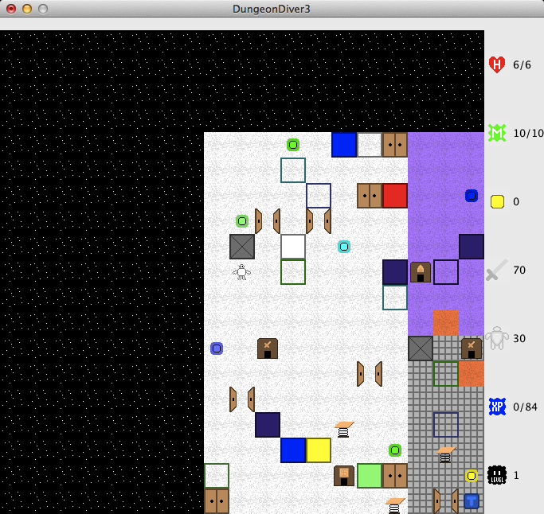
At the top, just below the window border, is the message area. When there is something to display, it shows up there. On the right side is the statistics display. The items shown are, from top to bottom: Health, Magic, Gold, Attack, Defense, Experience, and Monster Level. In the center is the dungeon itself. You are located in the center at all times.

Game Controls

To move, use the arrow keys – Up, Down, Left, and Right. You can also use the Numeric Keypad (make sure Num Lock is enabled), or the so-called "WAXD" configuration: W moves up, A moves left, D moves right, and X moves down. Additionally, diagonal movement is supported with WAXD: Q moves up and left, E moves up and right, Z moves down and left, C moves down and right. If you wish to move diagonally, the Numeric Keypad or the WAXD layout are the only ways to do this. Shift+Click an object to identify it. Its name will be displayed in the Message Area. If, for some reason, you need to make a "pass move" - that is, a do-nothing move, pressing 5 on the Numeric Keypad or the S key achieves this.

Expanding Dungeon Model

DungeonDiver3's dungeons dynamically expand as you explore deeper. Each dungeon starts out with only one area containing monsters at level 1. If you locate a Stairs Into and step on it for the first time, a new area containing level 2 monsters will be created, then you will be sent there. A Stairs Out takes you to an area that is easier in monster levels – these never occur on the topmost area (with level 1 monsters).

Dungeon Dangers

In these dungeons, the very ground you walk on may betray you. There are three kinds of hostile ground: Lava (orange), Water (dark blue), and Slime (light green). All kinds of hostile ground take health away from the entire party when stepped on: 5% of your Maximum HP, minimum 1. It is possible to die from too many steps on hostile ground.

The Race System
The Predefined Races, by Group
Humanoid Group: Dwarf, Elf, Gnome, Goblin, Human, Orc, Troll, Vampire
Robotic Group: Cyborg, Robot
Animal Group: Eagle, Lizard, Penguin, Turtle, Wolf
Undead Group: Ghost, Shade
Organic Group: Mush, Slime
Unknown Group: Demon

How many races are there? (I can't count the grouped list.)
Exactly twenty (20) predefined races exist.

How do the races compare against one another?
Good question. For those interested in this sort of thing, there's a table in the Appendix of Tables called Race Stat Growth. That's the place to look.

The Caste System
DungeonDiver3 has just four castes: Annihilator, Buffer, Curer, and Debuffer. Your caste determines what spell book you use as well as what weapon set you use.

The Faith System
How many faiths are there?
There are a total of 9 faiths: None, Heat, Cold, Rock, Gust, Beam, Dead, Bolt, and Boom.

What has a faith?
Each character in your party has a faith.
NPCs that join you also have a faith.
Even the monsters you fight have faiths.
Many spells and certain items are associated with a faith as well.

What are the effects of having a faith?
Faith affects skill with and defense against faith-aligned attacks and spells. Those who have the None faith have no skill or defense bonuses or penalties in any faith.

How do the faiths compare against one another?
Good question. For those interested in this sort of thing, there's a table in the Appendix of Tables called Faith Effectiveness. That's the place to look.

The Personality System
How many personalities are there?
There are a total of 25 personalities. They are listed in the Appendix of Tables.

What are the effects of having a personality?
Personality affects experience in battle, level up speed, wealth, carrying capacity, and movement.

How do the personalities compare against one another?
Good question. For those interested in this sort of thing, there's a table in the Appendix of Tables called Personality Data. That's the place to look.

Character Genders
What are the general effects of gender?
Character gender affects the results of equipping and using certain items. Some items can only be worn by or are only usable by one gender. Genders primarily exist to give flavor to your characters.

Character Prestige

As your character performs deeds both courageous and cowardly, their prestige will change. This is a score based on many different factors, such as the amount of enemies they have killed or how often they are hit themselves.

Things such as getting killed, missing in battle or failing to resist spells in battle can all affect your prestige in a negative way.

When you view Prestige Details, Scores in RED hurt your prestige, whereas BLUE scores help your prestige.

How prestige points are calculated:

Positive Prestige Points are calculated:

+ (Damage Given - Damage Taken) / 10 (This could be negative)
+ Hits Given
+ Attacks Dodged
+ 2 x Enemies Killed

Negative Prestige Points are calculated:

- Hits Taken
- 2 x Missed Attacks
- 3 x Number of Spells Cast in Battle
- 10 x Times You Were Killed In Battle
- 50 x Times You Ran Away In Battle

Gaining Levels

Defeating monsters in battle is the primary way of earning experience towards the next level. Any experience earned will be divided as evenly as possible between the members of your party who are still alive and conscious and have not fled from battle.

Damage and Death

If you get hit in battle, or step on hostile ground outside of battle, you suffer damage. If your health is reduced to 0 by this, you die.

Healing During Battle

If you know any healing spells, you may cast them while in battle on other party members, to restore lost health. To heal while outside battle, visit a healing shop.

Note Keeper

Notes may be created/edited while exploring the map by using the Edit Note... command in the Game menu. If a note is present on a particular space of the map, it will be indicated with a little N icon in the upper-right corner. Your notes are saved along with the rest of the game's state when you save your progress. You can only read notes on the space your party currently occupies.

Learning Spells

Spells are learned from Spell Shops. Spells may be learned in any order, if you possess enough Gold to do so.
Spell Power Levels
1, 2, 3, 4, 5, 6, 7, 8, 9, X

The cost to cast a given spell at each power level is equal to the spell's base cost (which is never 0) multiplied by the power level requested. The cost for a level X spell is 10 times the base cost.

Spell Damage

The various types of spell damage are inextricably linked to the various faiths. Each faith-aligned attack deals its own type of damage.

Battle

Battle is fought on a separate and randomly generated map, which is much smaller than the dungeon map. Battle in DungeonDiver3 is turn-based, which means that each creature involved in the battle gets a turn to act, until everyone has acted. Once that happens, a new round begins, and the cycle restarts anew. Battle ends once all hostile creatures are defeated, or your party is defeated.

Battle Special Actions

Pressing and holding the Shift key, then attempting to move when it is your turn in battle, will cause you to fire an arrow instead of moving. Arrows never miss, are considerably weaker than melee weapons, and follow faith rules when determining the damage done. Arrows never critically hit, and ignore enemy defenses when computing damage.
Battle Map
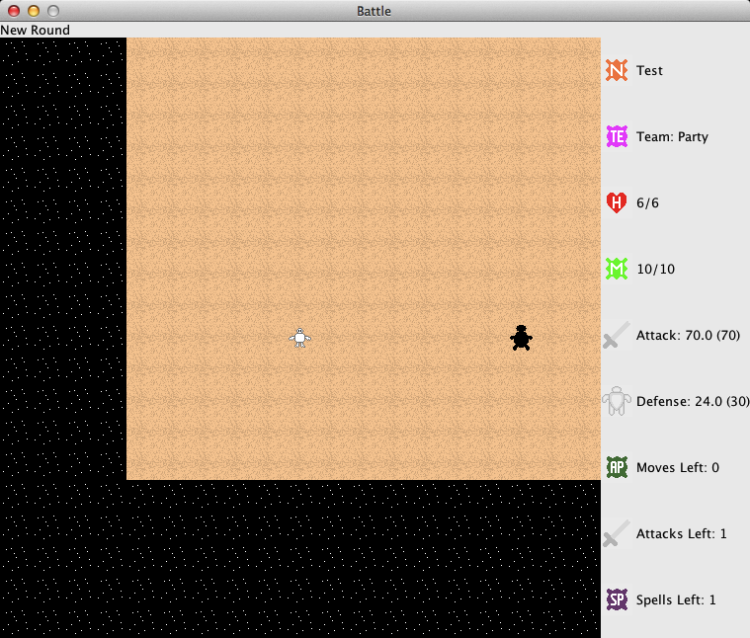
Above is a screenshot of one possible battle map. As with the dungeon map, the active character, which may not be you if one of the monsters is acting, is in the center. The message area at the top behaves in exactly the same way as the dungeon map version, as does the statistics display on the right.

Using Weapons to Attack

Moving is accomplished in the same way as on the dungeon map. To attack something, simply move into it.

Battle Weapon Attack Modifiers

Different things may happen when you attack an enemy in battle with your weapon.

Critical Hit: Occurs 20% of the time, deals double damage.
Piercing Hit: Occurs 10% of the time, ignores enemy defense when calculating damage.

It is possible for both events to occur at the same time. Both your party and the enemies can perform these actions.

Spell Casting Within Battle

To cast a spell, choose Cast Spell... from the Battle menu. A dialog will appear, asking for which spell to cast. After one is picked, a second dialog asks for the power level. After that, a third dialog prompts for a target to cast the spell at (except self-only spells). Finally, the spell is cast.

Running Away

To flee from battle, simply attempt to move off the edge of the battle map. You will be asked to confirm that you wish to embrace cowardice.

Attacking A Friendly Character

If you move into a friendly character, such as a member of your party, you will be asked to confirm that you wish to attack your friend. If you elect to attack anyway after this confirmation prompt, the attack will proceed as usual.

Other Battle Actions

To perform other actions in battle – casting spells, using items, stealing Gold, draining the enemy's MP, and ending your turn once you can do no more – go to the Battle Menu and choose the appropriate command. Keyboard shortcuts exist for all commands in the Battle Menu.

Items

Items are purchased from shops, and automatically equipped as soon as the transaction is completed. There are 4 kinds of shops that sell items: Weapon Shops, Armor Shops, Item Shops (which sell items usable in battle), and Socks Shops (items that act each time you take a step). Of the 4 types, only Item Shops sell items that are not equipment.

Enchantments for Equipment

Equipment can be improved in ways other than improving the base material from which it is made. Socks, however, cannot be enchanted. There are two kinds of enchantment available:

Blessing: Getting this on your equipment increases its effectiveness. Blessed items will have a +X suffix attached to them, where X is the number of times it has been blessed. Blessings increase the power of the item they are applied to. Blessings increase in cost as more are applied, and cannot be applied more than 9 times to a single item. Blessings are referred to as "Bonus" in the various equipment formulas.

Blessings are sold at Enhancement Shops, which can be easily distinguished from other shops by the large E on their doors.

Faith Power: Getting this on your equipment increases its effectiveness also. Faith Powered items will have a prefix attached to them, where the prefix is determined by the number of times it has been powered, as well as what Faith the power came from. Faith Powers do NOT increase the power of the item they are applied to. Faith Powers increase in cost as more are applied, and cannot be applied more than 9 times to a single item. A Faith Powered weapon will deal additional damage. Faith Powered armor reduces the damage you take, above and beyond what the armor itself provides.

Faith Powers are sold at Faith Power Shops, which can be easily distinguished from other shops by the large F on their doors.

World Wide Web

The OFFICIAL Putty Software web site: http://www.puttysoftware.com/
Appendix of Formulas

Formula 1: Equipment Power

Equipment Power = [Material (0 to 97) + Prefix (0 to 3)] x 10 + Bonus (-9 to 9)
Equipment Power Range: 1 to 999

Note: Bolded text in the formula represents the part to be evaluated next.

Example 1: Bamboo Stick -9 has power 1
Looking up Bamboo in the material table gives 1
Formula: (1 + 0) × 10 - 9
Simplifies to: 1 × 10 - 9
Simplifies to: 10 - 9
Final Answer: 1

Example 2: Rare Magic Axe +9 has power 999
Looking up Magic in the material table gives 97
Looking up Rare in the prefix table gives 2
Formula: (97 + 2) × 10 + 9
Simplifies to: 99 × 10 + 9
Simplifies to: 990 + 9
Final Answer: 999

Weapon Base (Maximum) Damage = Power (ignoring Bonus) / 10 (integer)
Weapon Bonus (Minimum and Maximum) Damage = Bonus (integer)
Armor % Damage Reduction = Power / 10 (floating-point)
Minimum % DR = 0 (no armor equipped)
Maximum % DR = 99.9 (999 / 10)

Note 1: Weapon minimum damage is 1, unless modified by a Bonus.
Note 2: Damage cannot be reduced below 1 by Damage Reduction.

Appendix of Lists

List 1: Numbers to Percentages Converter (Used for Resistance and Stat Growth)

15-point range, 0 to 14 (inclusive on both ends), default is 7
Percentage Scale (min 0, max 100, center 50) - used for magical resistance
0 = 0%
1 = 7%
2 = 14%
3 = 21%
4 = 29%
5 = 36%
6 = 43%
7 = 50%
8 = 57%
9 = 64%
10 = 71%
11 = 79%
12 = 86%
13 = 93%
14 = 100%

15-point range, -7 to 7 (inclusive on both ends), default is 0
Percentage Scale (min 50, max 150, center 100) - used for stats
-7 = 50%
-6 = 57%
-5 = 64%
-4 = 71%
-3 = 79%
-2 = 86%
-1 = 93%
0 = 100%
+1 = 107%
+2 = 114%
+3 = 121%
+4 = 129%
+5 = 136%
+6 = 143%
+7 = 150%

List 2: Statistics

Statistics Abbreviations, Descriptions, and Levels

Level Descriptions
Raw: A creature's basic stat.
Inherent: A basic stat for an equippable object or castable spell.
Factor: A modifier for a computed stat.
Computed: A stat with a value dependent on at least one raw stat, zero or one inherent stats, and at least one factor.
Effective: A stat that applies at action time and is computed only at that time.

Strength (STR)
Level: Raw
Description: Raw muscle of a creature.

Power (POW)
Level: Inherent
Description: The damaging ability of weapons and spells.

Strength-Attack Factor (SAF)
Level: Factor
Description: A multiplier that modifies the contribution of strength to attack.

Power-Attack Factor (PAF)
Level: Factor
Description: A multiplier that modifies the contribution of power to attack.

Attack (ATK)
Level: Computed
Description: (Strength * Strength-Attack Factor) + (Power * Power-Attack Factor)

Block (BLK)
Level: Inherent
Description: The absorbing ability of armor.

Block-Defense Factor (BDF)
Level: Factor
Description: A multiplier that modifies the contribution of block to defense.

Agility (AGI)
Level: Raw
Description: How fast a creature acts.

Agility-Defense Factor (ADF)
Level: Factor
Description: A multiplier that modifies the contribution of agility to defense.

Defense (DEF)
Level: Computed
Description: (Block * Block-Defense Factor) + (Agility * Agility-Defense Factor)

Damage (DMG)
Level: Effective
Description: Attack - Enemy Defense

Weight (WGT)
Level: Inherent
Description: How much an object slows down the creature wearing it.

Agility-Speed Factor (ASF)
Level: Factor
Description: A multiplier that modifies the contribution of agility to speed.

Weight-Speed Factor (WSF)
Level: Raw
Description: A multiplier that modifies the contribution of weight to speed.

Speed (SPD)
Level: Computed
Description: (Agility * Agility-Speed Factor) - (Weight * Weight-Speed Factor)

Initiative (INI)
Level: Effective
Description: Speed - Enemy Speed (if positive, you act first; if negative, enemy acts first; if zero, Luck difference used to break tie; if still tied, decided randomly)

Vitality (VIT)
Level: Raw
Description: A creature’s stamina.

Vitality-Health Factor (VHF)
Level: Factor
Description: A multiplier that modifies the contribution of vitality to maximum health.

Current Health (CH)
Level: Raw
Description: A creature’s overall health. If this drops below 1, the creature becomes dead. This cannot exceed the maximum health.

Maximum Health (MH)
Level: Computed
Description: Vitality * Vitality-Health Factor

Intelligence (INT)
Level: Raw
Description: A creature’s knowledge of the mystical arts.

Intelligence-Magic Factor (IMF)
Level: Factor
Description: A multiplier that modifies the contribution of intelligence to maximum magic.

Current Magic (CM)
Level: Raw
Description: A creature’s ability to use the mystical arts. If this drops below 1, the creature becomes unable to use mystical arts. This cannot exceed the maximum magic, nor can it drop below 0.

Maximum Magic (MM)
Level: Computed
Description: Intelligence * Intelligence-Magic Factor

Luck (LUC)
Level: Raw
Description: A creature’s likelihood of situations resolving in their favor.

Luck-Hit Factor (LHF)
Level: Factor
Description: A multiplier that modifies the contribution of luck to hit chance.

Differential-Hit Factor (DHF)
Level: Factor
Description: A multiplier that modifies the contribution of the difference between your attack and the enemy’s defense to hit chance.

Hit Chance (HIT)
Level: Computed
Description: (Attack - Enemy Defense) * Differential-Hit Factor + (Luck * Luck-Hit Factor)

Luck-Dodge Factor (LDF)
Level: Factor
Description: A multiplier that modifies the contribution of luck to dodge chance.

Differential-Dodge Factor (DDF)
Level: Factor
Description: A multiplier that modifies the contribution of the difference between the enemy’s attack and your defense to dodge chance.

Agility-Dodge Factor (ADF)
Level: Factor
Description: A multiplier that modifies the contribution of agility to dodge chance.

Dodge Chance (DDG)
Level: Computed
Description: (Enemy Attack - Defense) * Differential-Dodge Factor + (Luck * Luck-Dodge Factor) + (Agility * Agility-Dodge Factor)

List 3: Statistics Advancement

Stat Advancement

Raw Statistics
The six "core" raw statistics – Strength, Block, Agility, Vitality, Intelligence, and Luck – all change only when a level is gained.

Current Health changes when the creature is healed or suffers damage, and is NOT subject to the advancement rules above.

Current Magic changes when the creature regenerates, is drained, or casts a spell, and is NOT subject to the advancement rules above.

Maximum Health changes when Vitality changes.

Maximum Magic changes when Intelligence changes.
Appendix of Tables

Table 1: Equipment Raw Materials

Table 2: Race Stat Growth

Table 3: Personality Data

Table 4: Faith Effectiveness

